|  |
| --- |
| **ADDITIONAL INFORMATION TO REPORTING TABLES 1 – TOTAL COSTS AND UNIT COSTS** |

|  |
| --- |
| 1. **Determined costs and unit costs** |

|  |
| --- |
| **a) Description of the methodology used for allocating costs of facilities or services between different air navigation services, based on the list of facilities and services listed in ICAO Regional Air Navigation Plan, European Region (Doc 7754) as last amended, and a description of the methodology used for allocating those costs between different charging zones;** |

Fintraffic ANS (ANS Finland's name was 1.1.2021 changed to Fintraffic ANS) provides a) enroute services, b) terminal navigation services in Helsinki-Vantaa airport, c) terminal navigation services for Finavia’s network airports and d) training services. Cost allocation principles are following: enroute cost base includes all ACC costs, 40% of Helsinki-Vantaa airport’s ANS cost (TWR/APP) and 40% of ANS cost of 4 other airports, which have separate APP (Rovaniemi, Kuopio, Jyväskylä and Tampere).

Cost of technical ANS, administration and other centralized services are allocated to different cost bases by sharing keys, which differ by cost centers.

ANSP’s reported costs by nature and by services are based on Fintraffic ANS’s internal accounting and reporting system. Reported costs are based on ICAO’s Regional Air Navigation Plan (Doc 7754).

|  |
| --- |
| **b) Description of the methodology and assumptions used to establish the costs of air navigation services provided to VFR flights, when exemptions are granted for VFR flights in accordance with Article 31(3), 31(4) and 31(5);** |

Cost of VFR-fights are estimated by multiplying service units of VFR flights (from CRCO report) by enroute unit rate.

|  |
| --- |
| **c) Criteria used to allocate costs between terminal and en route services, in accordance with Article 22(5);** |

Fintraffic ANS’s costs are allocated to terminal and en route cost bases according to following principles

a) All ACC cost are allocated to en route cost base

b) All TWR cost are allocated to terminal cost base

c) APP cost are allocated to en route and terminal cost bases according to distance based rule.

a. Costs related to flight 0-20km from the airport are in terminal cost base

b. Costs related to flight over 20km from airport are in en route cost base.

c. 20 km has been chosen because according to charging regulation 20km is deducted from chargeable en route flight in both ends of the flight

d. For practical reasons costs of APP and TWR are in the same cost center. 40% of total TWR/APP costs are allocated to en route and 60% to terminal.

d) Costs of services common to both en route and terminal services are allocated in proportional way. These services include for example technical ANS, AIS and administration.

|  |
| --- |
| **d) Breakdown of the meteorological costs between direct costs and the costs of supporting meteorological facilities and services that also serve meteorological requirements in general (‘MET core costs’). MET core costs include general analysis and forecasting, surface and upper-air observation networks, meteorological communication systems, data processing centres and supporting core research, training and administration;** |

The cost accounting system of the Finnish Meteorological Institute (FMI) follows the principles of ABC (Activity-Based Costing). Method was implemented in 1995 and thus is the same principle as in RP2.

The costs of FMI are divided into two categories, direct costs and costs supporting meteorological facilities (indirect costs or MET core costs). Direct costs are assigned directly to the project in question. This assignment happens already in the book-keeping system of FMI. Direct costs can be labor costs and/or operational costs. The amount of labor costs consist of actual civil aviation labor input, working hours, which are recorded monthly to the working hour registry KIEKU.

There are two types of core cost items at FMI:

1. Costs of support services (general IT-infrastructure services, general training, financial and personnel administration etc.)

2. Unit-level costs (general management, public relations and internal communications, premises, electricity & water, office supplies and other unit-level costs)

The allocation of indirect costs/core costs to aviation has been made by using percentages. The more the unit is producing aviation services the higher the percentage is. The percentage is related to direct working hours. MET core costs are costs of infrastructure and supporting services, also met-institutes head office costs like International organizations member fees (EUMETSAT and WMO) are included in core costs. Core costs include both fixed and variable costs. Core costs can be labour and/or operational costs. Furthermore, the costs related to weather observations (including radar observations) are not included in these costs. The costs of observations are covered by the Finnish government budget funds.

|  |
| --- |
| **e) Description of the methodology used for allocating total meteorological costs and MET core costs referred to in point (d) to civil aviation and between charging zones;** |

The allocation of costs is based on the method described in the part d.

|  |
| --- |
| **f) For each entity, description of the composition of each item of the determined costs by nature and by service (points 1 and 2 of Table 1), including a description of the main factors explaining the planned variations over the reference period;** |

***Determined costs by nature and by service***

|  |  |
| --- | --- |
| **Entity: Fintraffic ANS** | |
| **1. Detail by nature (in nominal terms)** | |
| 1.1 Staff costs | Staff costs of certain cost centers according to allocation principles accepted by NSA. Staff costs include salaries, social security charges and pension costs.  In 2020 enroute staff costs were 15,8% (3,4M€) lower than in 2019. This saving was achieved mainly by temporary lay-offs and abandoning bonuses. In 2021 staff costs are expected to grow by 1,9%. In 2022 staff costs are expected to return to normal level (level before Covid-19). In 2023 and 2024 Staff costs are expected to grow about 4,5% due to traffic increase. One driver for the change is that ATCOs in Fintraffic ANS are older than before which increases age bonuses.  Fintraffic ANS age bonus scheme increases total salaries. This scheme applies to ATCOs and the average employee age is over 46 at the moment. The age bonus rises salaries every 4, 8, 11, 15 and 20 year one being employed.  Collective bargaining for years 2023-2024 is still ongoing and there isn't exact information for the general salary increases available yet.  It's also challenging to prepare for retirement in a timely manner. To avoid lack of personnel the recruitment and training of substitutes must begin well in advance. This causes occasionally overlapping resources. |
| of which, pension costs | Pension cost are expected to increase during RP3, because of increase in wages. Pension contributions are based on the gross wages. Employer % contribution rate is expected to be 16,95% in 2021 and 17,35% in 2022-2024. This estimate is made by the Finnish Centre for Pension. |
| 1.2 Other operating costs | Other operating costs include costs of material and services and other operating expenses. Main costs include ATM system and ICT costs, rents of premises, leasing cost of ANS assets and leasing costs of telecommunication lines. Other operating costs include also administrative costs of Fintraffic Group. These costs are related to ICT, HR, Financial services etc.  In 2020 other operating costs were 5,9% lower than in 2019 due to Covid-19 savings. In 2021 costs are expected to increase by 8,0%, in 2022 by 10,1%, in 2023 by 5,4% and in 2024 by 5,9%. Drivers for these changes are increases in travelling costs, payments to airport operator at Helsinki-Vantaa APP, cyber security and IT-security development costs and inflation. Costs of communication lines are increasing due to CPDLC enlargement to northern part of Finland. Management fee of Fintraffic is also expected to increase. Also the expansion of Datalink (SITA+ARINC) increases significantly deployment and maintenance costs. |
| 1.3 Depreciation | Depreciations of new and existing ANS assets according to Fintraffic ANS’s investment plan. Depreciations are expected to increase because of new investments.  Depreciations are based on Fintraffic ANS’s investment plan. Depreciations are planned to increase from 3,4M€ in 2020 to 4,5M€ in 2024. For RP3 Fintraffic ANS has planned many investments that will answer to capacity, safety and regulatory requirements (such as Regulation No 1207/2011 (requirements for the performance and the interoperability of surveillance for the single European sky) and Regulation No 2150/2005 (Implementation and Application of the Flexible Use of Airspace)), and is also improving cross-border cooperation with Estonia (FINEST project). Also European Implementation Plan (for example COM-11, ATC1.1) creates a demand for new investment projects for RP3.  Main investments by service categories:  SUR:   * Replacement of four existing en-route conventional radars * Deployment of Wide Area Multilateration * SMR and MLAT system evolution and system upgrade due to end-of-life and changes in Helsinki-Vantaa airport infrastructure   ATM:   * IP-ATM network infrastructure with secured communication * Main ATM system evolution for dynamic cross-border service provision, safety nets and monitoring aids * ASM system upgrade to comply with effective and dynamic airspace management * Implementation of ADQ compliant AIM system * ATM system evolution for enhanced surface management, monitoring and runway safety * Hardware renewals due to end-of-life for main ATM system both in operational and training environment   COM:   * Deployment of VoiP VCS system and radio equipment for new channel spacing requirement * IP-aviation network infrastructure with secured communication * DLS service extention * Services supporting the exchange of information over SWIM.   NAV:   * CNS system renewals both in en-route and busy terminal areas, mainly conventional equipment * Infrastructure evolution to comply with national NAV/SUR strategy   Training:   * System evolutions and hardware lifecycle renewals to comply with training of operational and technical staff |
| 1.4 Cost of capital | Cost of capital consists of asset base and WACC. WACC before tax in this calculation is 4,3%. Asset base increases in RP3 because of planned new investments. |
| 1.5 Exceptional items |  |
| **2. Detail by service (in nominal terms)** | |
| 2.1 Air Traffic Management | Staff costs of ATCO’s. Staff costs and other operating cost of technical ANS related to ATM. Depreciations and cost of capital of ATM investments. Costs of other centralized services (administration etc) |
| 2.2 Communication | Staff costs and other operating cost of technical ANS related to COM. Depreciations and cost of capital of COM investments. |
| 2.3 Navigation | Staff costs and other operating cost of technical ANS related to NAV. Depreciations and cost of capital of NAV investments. |
| 2.4 Surveillance | Staff costs and other operating cost of technical ANS related to SUR. Depreciations and cost of capital of SUR investments. |
| 2.5 Search and rescue | Costs of aeronautical rescue coordination centre |
| 2.6 Aeronautical Information | Costs of AIS unit and flight planning center allocated to en route service. |
| 2.7 Meteorological services |  |
| 2.8 Supervision costs |  |
| 2.9 Other State costs |  |
| **Adjustments beyond the provisions of the International Financial Reporting Standards adopted by the Union pursuant to Regulation (EC) No 1126/2008** | |
|  | |

|  |  |
| --- | --- |
| **Entity: FMI** | |
| **1. Detail by nature (in nominal terms)** | |
| 1.1 Staff costs | Staff costs of FMI staff members involved with civil aviation operational or development tasks in certain cost units. In general, 54% of FMI meteorological services costs are staff costs over the RP3 period. Staff costs are expected to rise by 1% on average and total FTEs expected to rise due to start of operations of the global Space Weather Centre as designated by ICAO. Staff costs include mandatory employer costs as determined by the State treasury.  2020 the determined costs are the same as the actual costs. Compared to the average set for RP3, 2020 Staff costs were higher than the determined average. This is due to increased need of manpower for number of changes in services, increase in wages and different distribution of costs between staff and operating costs from original determined costs. |
| of which, pension costs | Pension costs are expected to remain on average at 16,48% of total salary costs during RP3.  2020 the pension costs were 17.14%, a little bit higher than the determined average, due to increase in FMI pension costs. |
| 1.2 Other operating costs | In RP3 on average the remaining 46% of total costs are allocated to other operating costs. These include e.g. facility costs, administration, ICT services, reasonable share of membership fees to international organisations and outsourced services such as telecommunication lines to AFTN/AMHS centre.  2020 the determined costs are the same as the actual costs. Compared to the average set for RP3, 2020 other operating costs were lower than determined average due to different distribution of costs between staff and operating costs from original determined costs. |
| 1.3 Depreciation |  |
| 1.4 Cost of capital |  |
| 1.5 Exceptional items |  |
| **2. Detail by service (in nominal terms)** | |
| 2.1 Air Traffic Management |  |
| 2.2 Communication |  |
| 2.3 Navigation |  |
| 2.4 Surveillance |  |
| 2.5 Search and rescue |  |
| 2.6 Aeronautical Information |  |
| 2.7 Meteorological services | All FMI costs are allocated to meteorological services. Staff costs and operational costs of aeronautical meteorological forecast and warning centers, technical and support staff. Cost of operational centers, quality, compliance and development activities. Requirement for services imposed by (EU)2017/373 regulation, the Competent Authority and ICAO Annex 3, the overall staff cost regulations of the Finnish State and cost of services purchased from suppliers. Within the RP3 timeframe FMI cost-efficiency is influenced by the increase of regional and global services imposed by the regulation and ICAO designation of Space Weather Centres. Cost-efficiency is also affected by increasing staff costs, pension costs and cost increases in sub-contracted services, all contributing to small increases in overall costs. Operating costs for new services included in the Performance Plan for RP3 contribute positively to the overall productivity of FMI and increase total costs from 2020 onwards.  FMI is the Lead Member and operational centre of the Pan-European Consortium for Aviation Space Weather User Services (PECASUS), responsible for the management of the consortium and global dissemination of Space Weather Advisories. As one of three global Space Weather Centres, PECASUS is actively developing new services to mitigate impacts of hazardous space weather events to aviation. FMI Space Weather operations are funded by the Finnish State for the first three years of operations 2019-2021 after which the operational costs will be part of FMI MET costs from 2022 onwards, resulting in an increase in total costs annually. |
| 2.8 Supervision costs |  |
| 2.9 Other State costs |  |
| **Adjustments beyond the provisions of the International Financial Reporting Standards adopted by the Union pursuant to Regulation (EC) No 1126/2008** | |
|  | |

|  |  |
| --- | --- |
| **Entity: Traficom** | |
| **1. Detail by nature (in nominal terms)** | |
| 1.1 Staff costs | 50 % of the supervision costs are assessed to result from direct staff costs. |
| of which, pension costs |  |
| 1.2 Other operating costs | The other 50 % are assessed to be other operating costs which mainly consist of the agency’s overhead costs. 100 % of the Eurocontrol costs are other operating costs. |
| 1.3 Depreciation |  |
| 1.4 Cost of capital |  |
| 1.5 Exceptional items |  |
| **2. Detail by service (in nominal terms)** | |
| 2.1 Air Traffic Management |  |
| 2.2 Communication |  |
| 2.3 Navigation |  |
| 2.4 Surveillance |  |
| 2.5 Search and rescue |  |
| 2.6 Aeronautical Information |  |
| 2.7 Meteorological services |  |
| 2.8 Supervision costs | All the NSA costs are allocated to supervision costs. The nominal costs are planned to remain the same through the entire reference period.  NSA costs include Traficom’s infrastructure oversight charges. The charges are based on Act on Criteria for Charges Payable to the State and the target is that they are cost-reflective. NSA costs in enroute cost base consist from five airports which have APP control. 40 % of those airport’s infrastructure oversight charges are allocated to Enroute cost base.  In RP2 the method for charging each ATS-unit was based on the number of passengers. This method is being renewed for RP3 and the method is based on the number of IFR movements which reflects better the actual size of the ATS-unit and oversight work. This adjustment has increased the amount of NSA cost in enroute cost base comparing to RP2. |
| 2.9 Other State costs | Eurocontrol costs |
| **Adjustments beyond the provisions of the International Financial Reporting Standards adopted by the Union pursuant to Regulation (EC) No 1126/2008** | |
|  | |

***Pension costs***

*Note: The determined pension costs of the main ANSPs are detailed and justified in the body of the performance plan (item 3.4.3)*

|  |
| --- |
| **Entity: Fintraffic and FMI** |
| **Assumptions underlying the determined pension costs and expected evolution over Reference Period 3** |
| The statutory pension security in Finland consists of defined benefit earnings-related pension that accrues from work, as well as residence-based national pension and guarantee pension that ensure minimum security. In Finland, the earnings-related pension is a statutory benefit for the employee. The employer is liable to arrange pension insurance.  The employer arranges pension security for his employees from a pension provider of his own choosing. The employer can take out statutory pension insurance for the employees with a pension insurance company or with an industry-wide pension fund, or by establishing a company pension fund. State employers pay their contributions to the State Pension Fund.    Both the employer and the employee pay pension contributions based on the gross wage of the wage earner. The employer levies from the employee's wage/salary the employee's share of the contribution and pays it together with the employer's own contribution to the pension provider.    Contribution is mainly affected by the employer's size, which is evaluated on the basis of the total amount of wages and salaries paid by the employer.    Employers disburse pension contributions based on the earnings of their employees to their own pension providers, who use them to finance earnings-related pensions currently on their responsibility and, on the other hand, prepare for the payment of future pensions by funding payments.  Fintraffic's pension costs are covered by the Employees' Pensions Act (TyEL). Finnish Meteorological Institute's (FMI) pension costs are covered by the Public Sector Pensions Act (JuEL).    In September 2014, the Finnish central labour market organisations and the State agreed on an extensive pension reform that came into effect as of the beginning of 2017. This reform changed the sharing keys between the employer and employee. On average, this change lowered the employer's actual contribution for both TyEL and JuEL.  Underlying assumptions:  The level of statutory earnings-related contributions depends on the level on pension benefits, the currently valid funding and financing principles as well as investment profit from pension assets. Development of the national economy and the age structure of the population also affect the need for pension contributions.  The contribution rate and changes are set yearly by the State (TyEL and JuEL) and therefore are not under the control of the entity.  Contribution rate forecasts for RP3:  NSA has received the forecasts explained below from the service providers (ANSF and FMI).  Fintraffic ANS estimate contribution rate for 2022-2024 is from the Finnish Centre for Pension's forecast 20.1.2021.   |  |  |  |  |  |  | | --- | --- | --- | --- | --- | --- | | **Fintraffic ANS** |  |  |  |  |  | | EN-ROUTE |  |  |  |  |  | | "Determined" Pension costs (in DC,nominal) | 2020 | 2021 | 2022 | 2023 | 2024 | | Determined pensionable salary ('000€) | 15 071 | 15 070 | 18 409 | 19 223 | 20 084 | | Nber of pensionable staff | 189 | 189 | 192 | 195 | 198 | | % contribution rate (in DC) | 14,82 % | 16,95 % | 17,35 % | 17,35 % | 17,35 % | | Total pensions costs (as in DC '000€) | 2 234 | 2 554 | 3 194 | 3 335 | 3 485 |  |  |  |  |  |  |  | | --- | --- | --- | --- | --- | --- | | **FMI (MET)** |  |  |  |  |  | | EN-ROUTE |  |  |  |  |  | | "Determined" Pension costs (in DC,nominal) | 2020 | 2021 | 2022 | 2023 | 2024 | | Determined pensionable salary ('000€) | 1 194 | 1 068 | 1 194 | 1 190 | 1 182 | | Nber of pensionable staff | 23 | 23 | 23 | 23 | 23 | | % contribution rate (in DC) | 17,14 % | 16,48 % | 16,48 % | 16,48 % | 16,48 % | | Total pensions costs (as in DC '000€) | 204,652 | 176,006 | 196,771 | 196,112 | 194,794 | |

|  |
| --- |
| **g) For each entity, a description and justification of the method adopted for the calculation of depreciation costs (point 1.3 of Table 1): historical costs or current costs referred to in the fourth subparagraph of Article 22(4), and, where current cost accounting is used, provision of comparable historical cost data;** |

Depreciation is calculated using the straight line method on the historic cost of the assets.

In the separation of Fintraffic ANS (ANS Finland) from airport operator Finavia in 1.4.2017, it was decided that ANS assets at the airports are mainly owned by Finavia and Fintraffic ANS pays so called fixed assets-fee to Finavia for the use of these assets (leasing). Fixed assets-fee includes depreciation and cost of capital of Finavia and it is reported in Fintraffic ANS’s other operating cost. This change increases the other operating costs and decreases depreciations and cost of capital.

Fintraffic ANS provides services in rented premises so the depreciations do not include depreciations of buildings.

|  |
| --- |
| **h) For each entity, description and underlying assumptions of each item of complementary information (point 3 of Table 1), including a description of the main factors explaining the variations over the reference period;** |

|  |  |
| --- | --- |
| **Fintraffic ANS** | |
| **Costs of new and existing investments (see also performance plan item 2)** | |
| 3.10 Depreciation | Covered in item f) above |
| 3.11 Cost of capital | WACC before taxes (4,3%) is based on the calculation provided by the KPMG. In WACC calculation it has been assumed that 26,84% is financed via debt. |
| 3.12 Cost of leasing | To Finavia Fintraffic ANS pays “fixed assets-fee” for the use ANS assets owned by Finavia. Rent is based on depreciation and cost of capital of these assets. In the case of new investments Fintraffic ANS suggests new ANS investments for Finavia and Finavia makes final decision of the implementation. Fintraffic ANS provides project management services to Finavia in these projects. |

|  |  |
| --- | --- |
| **Eurocontrol costs** | |
| 3.13 Eurocontrol costs (Euro) | Eurocontrol costs 2020 and 2022-2024 are based on the figures of the Agency’s cost base received from the Eurocontrol by e-mail on 21.5.2021.  Eurocontrol cost for the year 2021 is the same which was received for the initial cost base reported in 15.12.2020. |
| 3.14 Exchange rate (if applicable) | Not applicable. |

|  |
| --- |
| **i) For each entity, description of the assumptions used to compute the cost of capital (point 1.4 of Table 1), including the composition of the asset base, the return on equity, the average interest on debts and the shares of financing of the asset base through debt and equity;** |

During RP3 the efficient model suggested by Steer Davies Gleave in their study on cost of capital, return on equity and pension costs of air navigation service providers is used as a guidance in WACC calculation. The same model as was used for RP2. According to the study, this model will ensure cost reflective charges and align with the broad objective of economic regulation to encourage an efficient allocation of resources across the economy.

Application of this option would require the following:

* The cost of equity to be calculated using the CAPM;
* The cost of debt should be estimated by reference to market borrowing rates;
* The assumed gearing should be the optimal level rather than the level actually prevailing when the calculation is made;
* The assumed risk free rate should be set by reference to government bond yields providing financial markets are relatively stable, and by reference to an appropriate comparator such as ECB bond rates otherwise;
* The asset beta should be within a recommended range of 0.3 to 0.5 unless the ANSP is able to justify a value outside the range; and
* All components of the calculation should be identified transparently and justified.

The actual WACC calculations has been prepared by KPMG on 28.6.2019 based on closing market data at 24.6.2019 (2020-2021) and the updated calculation on 16.9.2021 (2022-2024). **Updated WACC takes into account the comments received in user consultation and PRB's paper "Study on cost of capital, Methodology review and update". This lowers WACC from previous calculation which was presented in consultation.**

Summary of updated results:

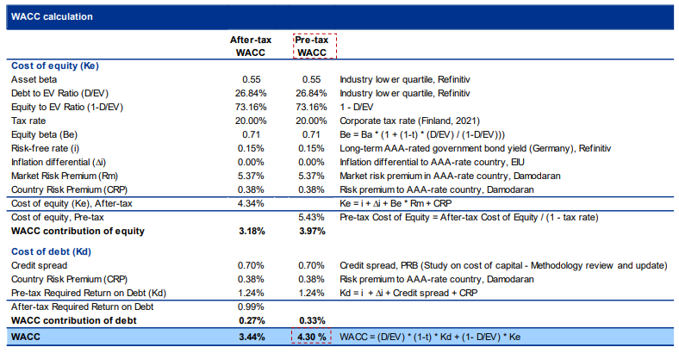

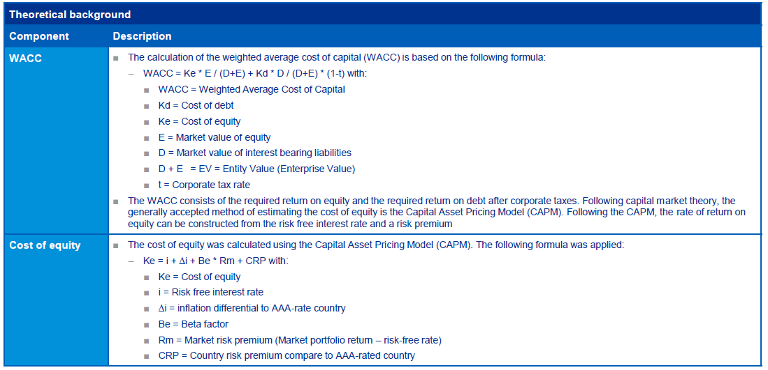

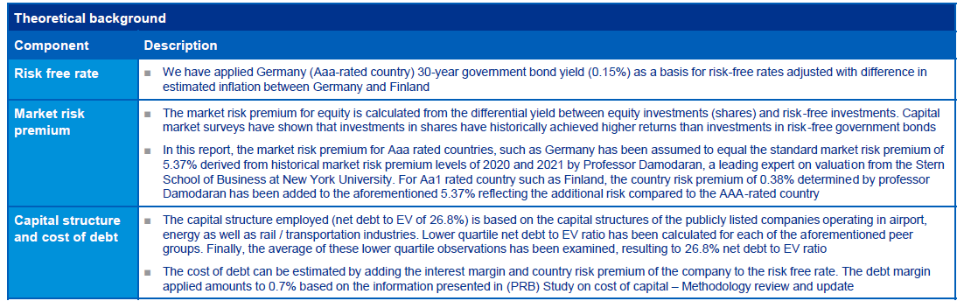

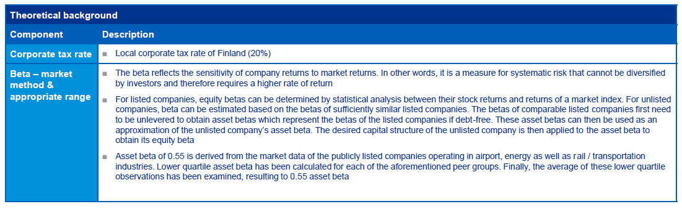

Peer group market information:

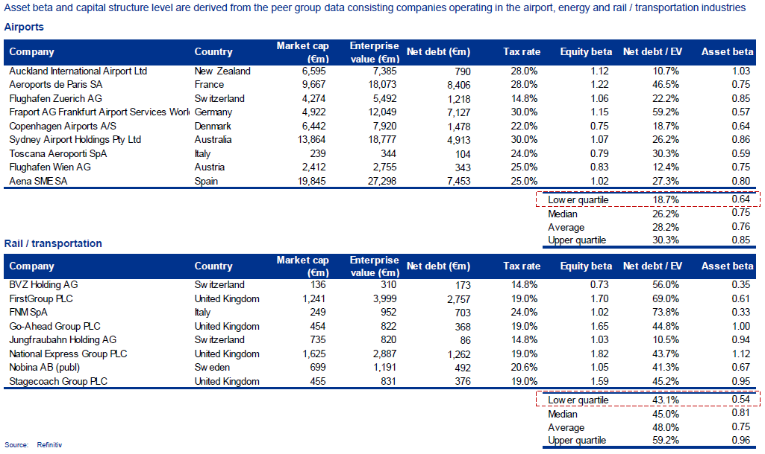

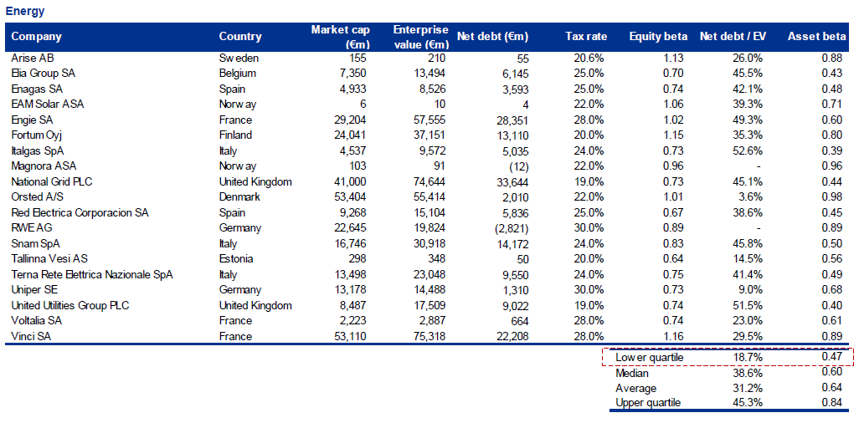

|  |  |
| --- | --- |
| **Fintraffic ANS** | |
| **Average asset base** | |
| 3.1 NBV fixed assets | NBV of fixed assets is expected to increase from 13,5 M€ in 2020 to 29 M€ in 2024 due to planned investment programme. NBV of fixed assets includes 5,8 M€ fixed assets under construction in average. |
| 3.2 Adjustments total assets |  |
| 3.3 Net current assets | Net current assets are estimated to be 1,8-2,9M€ in RP3. Net current assets consist of Fintraffic ANS sales receivables less trade accounts payable. 50 % of these are allocated to en-route cost base. |
| **Cost of capital %** | |
| 3.6 Return on equity | Pre-tax return on equity 4,3% is based on KPMG’s calculation. |
| 3.7 Average interest on debts | The debt margin applied amounts to 0.7% based on the information presented in (PRB) Study on cost of capital. |
| 3.8 Share of financing through equity | WACC calculation is updated. Peer group used as a proxy for optimal gearing (share of equity 73,16%). |

|  |
| --- |
| **j) Description of the determined costs of common projects (point 3.9 of Table 1).** |

|  |  |  |  |  |  |
| --- | --- | --- | --- | --- | --- |
| **Fintraffic ANS** | | | | | |
| **Determined costs of common projects (in nominal terms in ‘000 national currency)** | | | | | |
| **CP reference** | **2020** | **2021** | **2022** | **2023** | **2024** |
| AF3 | 1 730 278 | 2 590 659 | 2 967 874 | 3 799 040 | 4 713 938 |
| AF6 | 0 | 29 059 | 76 064 | 88 603 | 99 127 |
| **Total (Table 1 item 3.9)** | 1 730 278 | 2 619 718 | 3 043 937 | 3 887 644 | 4 813 064 |

|  |
| --- |
| 1. **Actual costs and unit costs** |

|  |
| --- |
| **a) For each entity and for each cost item, a description of the reported actual costs and the difference between those costs and the determined costs, for each year of the reference period;** |

2020-2021

|  |  |
| --- | --- |
| **RP3 Monitoring – Year 2020-2021** | |
| **ANSP: Fintraffic ANS** | |
| 1.1 Staff costs | Actual costs of 2020 were the same as determined costs in updated performance plan. All difference comes from year 2021. Actual staff costs of 2020-2021 were 4,0% lower than planned due to temporary lay-offs, lower head count, abandoning bonuses, lower pension costs, postponing recruiting and other savings in staff costs. |
| 1.2 Other operating costs | Actual other operating costs in 2020-2021 were 6,0% (1,3M€) lower than determined costs due to savings in many cost groups: voluntary staff costs (health cost, training, parking) and travel costs due to remote work, less payments to airport operator (Finavia) due to new contracts related to HR and ICT, lower telecommunication costs, lower credit losses, less purchases of equipment and spare parts, purchases from military (ATCO) and LFV (ATCO service for Kvarken flights) were lower, costs of operative ICT services lower than planned. |
| 1.3 Depreciation | Depreciations were 2,6% (197k€) lower than planned due to postponing investments |
| 1.4 Cost of capital | Cost of capital was 14,9% (225k€) lower than planned due to postponing investments |
| 1.5 Exceptional items |  |

|  |  |
| --- | --- |
| **RP3 Monitoring – Year 2020-2021** | |
| **ANSP: MET/FMI** | |
| 1.1 Staff costs | The actual costs are higher than determined costs due to increase in wages and pension costs, increased need of manpower for number of changes in services and different distribution of costs between staff and operating costs from determined costs. |
| 1.2 Other operating costs | The actual costs are lower than determined costs due to different distribution of costs between staff and operating costs. |
| 1.3 Depreciation |  |
| 1.4 Cost of capital |  |
| 1.5 Exceptional items |  |

|  |  |
| --- | --- |
| **RP3 Monitoring – Year 2020-2021** | |
| **STATE/NSA: Traficom** | |
| 1.1 Staff costs | Lower operation levels didn't have an effect on supervision costs. The ATS-units concerned remained in the same supervision charge range. |
| 1.2 Other operating costs | Eurocontrol actual costs were lower than determined. |
| 1.3 Depreciation |  |
| 1.4 Cost of capital |  |
| 1.5 Exceptional items |  |

2022

|  |  |
| --- | --- |
| **RP3 Monitoring – Year 2022** | |
| **ANSP: Fintraffic ANS** | |
| 1.1 Staff costs | Actual staff costs in 2022 were 11,6% (2,6M€) lower than planned due to temporary lay-offs, lower head count, abandoning bonuses, lower pension costs, postponing recruiting and other savings in staff costs. These savings were made, because lower traffic due war in Ukraine. |
| 1.2 Other operating costs | Actual other operating costs in 2022 were 9,9% (1,2M€) lower than determined costs due to savings in many cost groups: lower Group service fees (HR, Accounting ICT), voluntary staff costs (health cost, training, parking) and travel costs due to remote work, less payments to airport operator (Finavia) due to new contracts related to HR and ICT, lower telecommunication costs, lower credit losses, less purchases of equipment and spare parts, purchases from military (ATCO) and LFV (ATCO service for Kvarken flights) were lower. |
| 1.3 Depreciation | Depreciations were 23,9% (788k€) lower than planned due to postponing investments |
| 1.4 Cost of capital | Cost of capital was 41,1% (448k€) lower than planned due to postponing investments |
| 1.5 Exceptional items |  |

|  |  |
| --- | --- |
| **RP3 Monitoring – Year 2022** | |
| **ANSP: MET/FME** | |
| 1.1 Staff costs | The actual costs are higher than determined costs due to increase in wages and pension costs, increased need of manpower for number of changes in services and different distribution of costs between staff and operating costs from determined costs. |
| 1.2 Other operating costs | The actual costs are lower than determined costs due to different distribution of costs between staff and operating costs. |
| 1.3 Depreciation |  |
| 1.4 Cost of capital |  |
| 1.5 Exceptional items |  |

|  |  |
| --- | --- |
| **RP3 Monitoring – Year 2022** | |
| **STATE/NSA: Traficom** | |
| 1.1 Staff costs | Lower operation levels didn't have an effect on supervision costs. The ATS-units concerned remained in the same supervision charge range. |
| 1.2 Other operating costs | Eurocontrol actual costs were lower than determined. |
| 1.3 Depreciation |  |
| 1.4 Cost of capital |  |
| 1.5 Exceptional items |  |

|  |
| --- |
| **b) Description of the reported actual service units and a description of any differences between those units and the figures provided by the entity that is billing and collecting charges as well as any differences between those units and the forecast set in the performance plan, for each year of the reference period;** |

2020-2021 actual service units were 1,4 % higher than determined SUs due to slightly better traffic evolution towards the end of 2021 than expected.

2022 actual service units were 33 % lower than determined SUs. The closure of Russian airspace had a significant impact on the traffic in Finland.

|  |
| --- |
| **c) Breakdown of the actual costs of common projects per individual project;** |

|  |  |  |  |  |  |
| --- | --- | --- | --- | --- | --- |
| **Fintraffic** | | | | | |
| **Determined costs of common projects (in nominal terms in ‘000 national currency)** | | | | | |
| **CP reference** | **2020** | **2021** | **2022** | **2023** | **2024** |
| AF3 | 1 730 278 | 2 287 743 | <…> |  |  |
| AF6 | 0 |  |  |  |  |
| **Total (Table 1 item 3.9)** | **1 730 278** | **2 287 743** | <…> |  |  |

|  |
| --- |
| **d) Justification of the difference between the determined and the actual costs of new and existing investments of the air navigation service providers, as well as the difference between the planned and the actual date of entry into operation of the fixed assets financed by those investments for each year of the reference period;** |

2020-2021

Determined vs. actual difference

General: adaptation of investment implementations performed during the whole pandemic timeframe and continues in this geopolitical situation. The reason is lack of economical and personnel resources.

ATM – TopSky SW and HW lifecycle upgrade postponed. Deployment delayed until end of 2023. FINEST investments postponed because MoD did not approve FINEST cross-border service provision and related data sharing.

COM – VCS VoIP deployment postponed until Q2/2023

SUR – MSSR lifecycle upgrades executed with lower costs.

NAV – some delays in DME lifecycle renewals

2022

<…>

|  |
| --- |
| **e) Description of the investment projects added, cancelled or replaced during the reference period with respect to the major investment projects identified in the performance plan, and approved by the national supervisory authority in accordance with Article 28(4).** |

2020-2021

No major investment projects.

2022

No major investment projects.

|  |
| --- |
| **ADDITIONAL INFORMATION TO REPORTING TABLES 2 – UNIT RATE CALCULATION** |

|  |
| --- |
| **a) Description and rationale for establishment of the different charging zones, in particular with regard to terminal charging zones and potential cross-subsidies between charging zones;** |

Finland has one enroute charging zone

|  |
| --- |
| **b) Description of the policy on exemptions and description of the financing means to cover the related costs;** |

2020-2021

Actual costs incurred in relation to services to flights exempted from ANS charges (pursuant to Article 31(3) to (5) and Article 22(6) of Implementing Regulation (EU) 2019/317) in the charging zone in 2020.

|  |  |
| --- | --- |
|  | **2020** |
| Costs for exempted VFR flights | 1k€ |
| Costs for exempted IFR flights | 91k€ |
| **Total costs for exempted flights** | **92k€** |

Fintraffic ANS has contract with Finnish Airforce to cover the cost of military flights. For other exempted flights there is no financing for the time being.

Actual costs incurred in relation to services to flights exempted from ANS charges (pursuant to Article 31(3) to (5) and Article 22(6) of Implementing Regulation (EU) 2019/317) in the charging zone in 2020.

|  |  |
| --- | --- |
|  | **2021** |
| Costs for exempted VFR flights | 1k€ |
| Costs for exempted IFR flights | 10k€ |
| **Total costs for exempted flights** | 11k€ |

Fintraffic ANS has contract with Finnish Airforce to cover the cost of military flights. For other exempted flights there is no financing for the time being.

2022

Actual costs incurred in relation to services to flights exempted from ANS charges (pursuant to Article 31(3) to (5) and Article 22(6) of Implementing Regulation (EU) 2019/317) in the charging zone in 2022.

|  |  |
| --- | --- |
|  | **2022** |
| Costs for exempted VFR flights | <…> |
| Costs for exempted IFR flights | <…> |
| **Total costs for exempted flights** | <…> |

Description of the financing means covering the costs incurred for services provided to exempted flights in 2022.

<…>

Flights which have been exempted from the payment of navigation charges in Finland:

1. mixed VFR/IFR flights only in the airspace of the Flight Information Regions falling within the competence of the Contracting State or States where they are performed exclusively under VFR and where a charge is not levied for VFR flights;
2. flights performed by aircraft of which the maximum take-off weight authorised is less than two (2) metric tons;
3. flights performed exclusively for the transport, on official mission, of the reigning Monarch and his/her immediate family, Heads of State, Heads of Government, and Government Ministers. In all cases, this must be substantiated by the appropriate status indicator on the flight plan;
4. search and rescue flights authorised by a competent SAR body;
5. military flights of any Contracting State; (Fintraffic ANS/Finavia has separate contract with the Finnish Air Force concerning services and air traffic charges, including en route charges)
6. training flights performed exclusively for the purpose of obtaining a licence, or rating in the case of cockpit flight crew, and where this is substantiated by an appropriate remark on the flight plan. Flights must be performed solely within the airspace of the State concerned. Flights must not serve for the transport of passengers and/or cargo, nor for positioning or ferrying of the aircraft;
7. flights performed exclusively for the purpose of checking or testing equipment used or intended to be used as ground aids to air navigation, excluding positioning flights by the aircraft concerned;
8. flights terminating at the aerodrome from which the aircraft has taken off during which no intermediate landing has been made (circular flights).

Main part of exempted flights in Finland consists of military flights. These flights are financed by the military.

|  |
| --- |
| **c) Description of adjustments resulting from the traffic risk sharing mechanism in accordance with Article 27;** |

2020-2021

No traffic risk sharing from 2020-2021, traffic deviation less than 2 %.

2022

Actual traffic was 33 % lower than determined. This leads to a traffic risk sharing adjustment to year n+2 (2024) total of 11 200 M€.

|  |
| --- |
| **d) Description of the differences between determined costs and actual costs of year n as a result of the changes in costs referred to in Article 28(3) including description of the changes referred to in that Article;** |

2020-2021

ANSP actual leasing costs were the same as determined but depreciation costs were slightly lower than determined. MET pension costs were higher and ANSP pension costs lower than determined (the uncontrollable part of pension costs). Eurocontrol costs were lower than determined.

2022

ANSP actual depreciation and capital costs were lower than determined. ANSP pension costs were slightly lower and MET pension costs higher than determined (the uncontrollable part of pension costs). Eurocontrol costs were lower than determined.

|  |
| --- |
| **e) Description of adjustments resulting from unforeseen changes in costs in accordance with Article 28(3) to (6);** |

2020-2021

Cost exempt from cost risk sharing are reimbursed/recovered in RP4 except Eurocontrol costs which are reimbursed in year n+2 (2023).

2022

Cost exempt from cost risk sharing are reimbursed/recovered in RP4 except Eurocontrol costs which are reimbursed in year n+2 (2023).

|  |
| --- |
| **f) Description of the other revenues, if any, broken down between the different categories indicated in Article 25(3);** |

2020-2021

**Revenues from union assistance programs allocated to enroute charging zone (Table 4)**

In Table 4 are the projects which have received revenues from CEF/INEA funding. TEN-T funding has not been reported in this table. Value of these projects is 31 M€ and amounts granted 15,5 M€. Amount received until now is 6,2 M€ (amounts returned to INEA are taken into account). Amounts retained in respect of administrative cost includes a share of FPA coordination fee. Amounts reimbursed to users are presented in table below.



**Other ‘Other revenues’**

Fintraffic ANS receives income from the Finnish Defence forces related to military flights. Reported income relates to those military flights not included in total service units.

The reimbursement to users because of the unspent CAPEX in RP2, total of 1,2 M€ (0,24 M€/year), is reported in the revenues from commercial activities.

Fintraffic ANS received in 2020 state fund in total 2,9 M€ and in 2021 in total 3,1 M€. These are reported in other income and planned to be reimbursed in year n+2 (2022 and 2023).

2022

**Revenues from union assistance programs allocated to enroute charging zone (Table 4)**

**"Difference between received EU-funding and EU-funding transferred to airlines"**

**Other 'Other revenues'**

Fintraffic ANS receives income from the Finnish Defence forces related to military flights. Reported income relates to those military flights not included in total service units.

The reimbursement to users because of the unspent CAPEX in RP2, total of 1,2 M€ (0,24 M€/year), is reported in the revenues from commercial activities.

Fintraffic ANS received in 2022 state fund in total 3,2 M€. This is reported in other income and planned to be reimbursed in year n+2 (2024).

|  |
| --- |
| **g) Description of the application of the financial incentive schemes referred to in Article 11(3) and 11(4) in year n and the resulting financial advantages and disadvantages; description and explanation of the modulation of air navigation charges applied in year n under Article 32 where applicable, and resulting adjustments;** |

***Financial incentive schemes***

The description and justification of the parameters of the incentive scheme defined in accordance with Article 11(3) and 11 (4) are provided in the body of the performance plan under item 5.2.

***Modulation of charges***

Not applicable

2020-2021

The actual application and relating financial advantages and disadvantages for 2020-2021 is not applicable (Exceptional measures for RP3 due to the COVID-19 pandemic (Regulation (EU) 2020/1627, Article 3 (3)).

2022

N/A

|  |
| --- |
| **h) Description of adjustments relating to the temporary application of a unit rate under Article 29(5);** |

Difference in revenue due to the temporary application of unit rate in 2020-2021 is 34.276.077 € and is reimbursed over five years (starting 2023) according to the Art. 5(5) ((EU) 2020/1627).

|  |
| --- |
| **i) Description of the cross-financing between en route charging zones, or between terminal charging zones, in accordance with point (e) of Article 15(2) of Regulation 550/2004;** |

No cross-financing applied.

|  |
| --- |
| **j) Information on the application of a lower unit rate under Article 29(6) than the unit rate calculated in accordance with Article 25(2) and the means to finance the difference in revenue;** |

No lower unit rate applied.

|  |
| --- |
| **k) Information and breakdown of the adjustments relating to previous reference periods impacting the unit rate calculation;** |

Traffic risk sharing up to 2017 (7488 M€): Under recoveries were allocated to years 2020 and 2021.

Cost exempt from cost sharing up to 2017 and 2018-2019 (1533 M€) was allocated to year 2022.

Other carry-overs and adjustments are allocated as defined in the SES legislation. This also applies to 2019 traffic risk and inflation reimbursements which were allocated to year 2021.

|  |
| --- |
| **ADDITIONAL INFORMATION TO REPORTING TABLE 3 – COMPLEMENTARY INFORMATION ON COMMON PROJECTS AND ON UNION ASSISTANCE PROGRAMME** |

|  |
| --- |
| **l) Information on the costs of common projects and other funded projects broken down per individual project, as well as of public funds obtained from public authorities for these projects.** |

Fintraffic ANS has been granted CEF co-funding ca. 15,5 M€ during the years 2016-2019. That is maximum 50% of the budgeted total costs (i.e. 31,1 M€). Until now the co-fundings received are ca. 7,3 M€ but 1,1 M€ of that was to reimbursed for SESAR Deployment Manager (acting as Grant Agreement Coordinator) due to delayed projects and their delayed costs – so the received amount of co-funding until now totals ca. 6,2 M€.

Fintraffic ANS has compensated the received co-funding towards the airlines by lowering its unit rates. In 2017 the compensation was 3 k€, in 2018 458k€ and in 2019 1197k€ totalling 1659 k€. In 2020 compensation was 107 k€ for OPEX co-fundings and 395k€ for CAPEX co-funding. In 2021 Compensation is 302k€. No compensation in 2022. In 2023 and 2024 planned compensation is 367k€ per year.

The schedule for further compensations will be dependent on exact date of finalization of the supported actions. The principle is that compensation for OPEX co-fundings will be made two years after received co-funding and compensation for CAPEX co-fundings will be made according to depreciation period after taking the systems in use.

See Table 2 f) Description of other revenues.

**Ongoing pilot common projects and foreseen costs in RP3:**

Pilot common projects Family AF3:

* CEF 2014: 020AF3 - Borealis Free Route Airspace (Part 1)
* to be finished by 2020
* personnel and travel costs
* no other public funding
* CEF 2015: 2015_227_AF3_A - Borealis FRA Implementation (Part 2)
* to be finished by 2023
* personnel and travel costs
* investments and systems installation costs – depreciation costs for RP3
* no other public funding
* estimated costs for AF3 Free Route airspace components implementation during RP3
* personnel and travel costs
* investments and systems installation costs
* no other public funding

Pilot common projects Family AF5:

* CEF2015: 015_174_AF5_A - NewPENS Stakeholders contribution for the procurement and deployment of NewPENS
* to be finished by 2020
* personnel and travel costs
* investments and systems installation costs - depreciation costs for RP3
* no other public funding
* CEF2016: 2016_141_AF5 - Deploy SWIM Governance
* to be finished by 2020
* personnel and travel costs
* no other public funding
* CEF2016: 2016_027_AF5 - European Deployment Roadmap for Flight Object Interoperability
* to be finished by 2020
* personnel and travel costs
* no other public funding
* CEF2017: 2017_084_AF5 - SWIM Common PKI and policies & procedures for establishing a Trust framework
* to be finished by 2020
* personnel and travel costs
* no other public funding
* estimated costs for AF5 SWIM Yellow profile and SWIM blue profile implementation during RP3
* personnel and travel costs
* investments and systems installation costs
* no other public funding

Pilot common projects Family AF6:

* CEF2016: 2016_159_AF6 - DLS Implementation Project - Path 2
* to be finished by 2020
* personnel and travel costs
* no other public funding
* estimated costs for AF6 DLS implementation during RP3
* personnel and travel costs
* investments and systems installation costs
* no other public funding